Holmhirst Pre School
COVID19 Procedures
February 2022

Parents / Carers,
The pandemic continues and the rise in cases continues. We review our measures regularly to protect our users and us as a Pre School. Please find below details of our updated procedures to reflect the current COVID19 situation and the impact of COVID19on our Pre School day.
Please adhere to these procedures so we can maintain a level of safety.

Arrivals & Departures:
- Be mindful of how you travel to Pre School to drop off or collect your Child. Avoid public transport wherever possible. DO NOT offer other families a ‘lift’ or to collect your child.
- Drop off & Collection times will continue to be flexible, (between 8.45am & 9am & collection from 2.45pm).This will avoid congestion.
- We are requesting only 1 Parent / Carer drop off & collect their Child. This avoids congestion at arrival & departure times, and minimises the risk of transmission.
- STAFF & CHILDREN WILL CONTINUE TO HAVE THEIR TEMPERATURE TAKEN ON ARRIVAL.
- WE ARE ENCOURAGING PARENTS / CARERS TO WEAR A FACE COVERING WHEN DROPPING OFF OR COLLECTING YOUR CHILD. EXEMPTION RULES APPLY.
- Please wash your hands & your child’s hands before leaving home.
- PLEASE COVER ANY EXISTING SORES / WOUNDS WITH A PLASTER / DRESSING BEFORE ATTENDING PRE SCHOOL.
- Please distance yourself from Staff and other Parents / Carers as much as possible.
- Parents are asked to wait outside the gate with their Child until the person in front of you has moved away from the gate.
- Please maintain social distancing wherever possible whilst waiting outside the gate, keeping distance from the next Parent / Carer / Child. Please queue to the right of the gate as you approach.
- Pre School Staff will wear face coverings to admit the Children and talk to Parents / Carers, as well as when Children depart and any other activity that requires close contact, e.g changing a Child, helping with coats / clothing etc.
- The same procedure applies when collecting your Child at the end of the day. A member of Staff will hand your Child over in a reverse manner to the morning procedure.
- Parents of new Children will be allowed to come in to the Pre School to settle them.
- FROM FEBRUARY 2022 PARENTS ENTERING THE PRE SCHOOL WILL REQUIRE PROOF OF A LATERAL FLOW TEST TAKEN ON THAT DAY. YOU WILL NEED TO SHOW NOTIFICATION OF THE TEST ONCE YOU HAVE REGISTERED IT ON GOV.UK.
- PARENTS / CARERS WILL HAVE TO HAVE TO AGREE TO A TEMPERATURE CHECK BEFORE ENTRY INTO THE PRE SCHOOL.

Activities / Grouping:
- The Children will be operating in one ‘Bubble’ in line with Government guidelines. However, protective measures are in place to avoid as much contact as possible.
- The daily group will have regular members of Staff who will operate activities throughout the day and be responsible for their own social distancing wherever possible.
- Activity areas will be cleaned regularly to minimise transmission.

Illness & Children presenting unwell:
As social restrictions are more relaxed, it is inevitable that Children will be mixing out of Pre School more. This may result in Children picking up more colds etc. Our practice will continue by not admitting Children who present unwell or become unwell during a Pre School day. This will remain in place until we are confident that the COVID pandemic is under control. The current Government guidelines require us to continue with manageable procedures.
- Please DO NOT bring your Child to Pre School if they are unwell or appear unwell or generally under the weather.
- Pre School reserves the right to refuse admission to any Child who presents unwell.
- DO NOT GIVE YOUR CHILD TEMPERATURE REDUCING MEDICINE / IBUPROFEN ETC. BEFORE BRINGING THEM TO PRE SCHOOL!!!
- If your Child requires temperature reducing medicine (e.g Calpol) before they arrive, then they are deemed unfit to attend.
- We will continue to be strict on only admitting Children who present well.
- Any Child presenting unwell during session will be separated from the main group until the Parent collects. Staff will supervise them wearing full PPE, but will maintain a 2m distance wherever possible in line with current guidelines. Staff will monitor temperatures of all children during the day.
- Parents will be contacted immediately if their Child appears to be unwell.
- PARENTS WILL BE ASKED TO TAKE THEIR CHILD FOR A PCR TEST IF THEY PRESENT WITH A RAISED TEMPERATURE. A raised temperature is one of the defined symptoms on the Government website requiring a PCR Test.
- Children can return to Pre School on receipt of a Negative PCR test or 2 Negative Lateral Flow tests in line with Government guidelines following a positive case.
- If anyone in your household / childcare bubble / close contact is symptomatic or awaiting COVID Test results can you let alert the Pre School.
- Parents can access Lateral Flow test kits for family members to regularly test. However, Children & family members who present as symptomatic should access a PCR test immediately via the NHS ONLINE service.
- Parents of Children who attend two settings should inform the Pre School if there is an outbreak in the other setting. This will enable us to risk assess the situation.

Visitors to Pre School:
- Visitors will not be allowed to enter the Pre School unless essential. Any deliveries will be left in the outdoor area, and brought in by Staff.
- Professionals visiting Children with additional needs will be admitted dependent on agreeing to a temperature check, and proof of a LFT.
- Parents dropping forgotten lunch bags etc. will not be allowed in to Pre School and should alert Staff at the gate or by a prior telephone call to alert your arrival.
- IF IT IS ABSOLUTELY ESSENTIAL FOR A PARENT / ADULT / VISITOR TO ENTER THE PRE SCHOOL A FACE MASK / COVERING MUST BE WORN UNLESS THEY CAN PROVE EXEMPTION.THIS IS TO MINIMISE TRANSMISSION. THE VISITOR MUST AGREE TO A TEMPERATURE CHECK PRIOR TO ENTRY.

Snack & Lunch arrangements:
- Children & Staff will be required to wash hands before and after lunch.
- Staff will help children with packets / yoghurt tops / containers etc. and will avoid over handling packets etc. The member of Staff will wash their hands and wear protective gloves to help a child open a packet / container. Once they have finished helping a Child they will rewash their hands and discard their gloves.
- Any uneaten food will be discarded after the child has finished their lunch. Please only send what they are going to eat as the remainder will be thrown away.

Handwashing:
- Public Health England advises that Children and Staff should be encouraged to catch sneezes with a tissue, bin the tissue and wash their hands.
- We follow the CATCH IT – BIN IT – KILL IT procedure. We are teaching Children to cough into their sleeve to minimise transmission.
- Parents & Children should wash their hands before they leave home.
- We will rewash their hands when they arrive at the Pre School
- We will also insist the children wash their hands:
- After outside breaks
- After sneezing / wiping their nose
- Before meals and snack times
- After using the toilet
- At the end of the day before they go home.
- Periodically as routine during the day.

PPE:
- Staff will wear the appropriate PPE in line with the Government guidance for Education settings.
- Our pre COVID19 practise was to wear Apron, Gloves and rigorously hand wash when changing a Child so the Children are used to seeing us ‘gown up’ so to speak.
- Face masks will be worn by Staff in any close contact activity with Children e.g, Changing a Child / helping them with their coats / clothing / dressing etc. / any situation which requires a close contact position.

Government Updates Self-Isolation rules:

The government are continuingly updating guidance on what an individual should do if they are confirmed as a contact of a positive Covid-19 case.
As of December 2021, certain groups can take a lateral flow test every day for seven days instead of isolating, if they have been identified as a close contact of a suspected or confirmed case of any variant of Covid-19 (including Omicron). Please visit the Government website for the latest Self Isolation guidance.

The self-isolation advice for people with COVID-19 is constantly changing. It is now possible to end self-isolation after 5 days, following 2 negative LFD tests taken 24 hours apart. Government guidance rules apply. See GOV.UK for up to date guidance.

Examples of when to end self-isolation if you have had COVID-19 symptoms or have received a positive COVID-19 test result
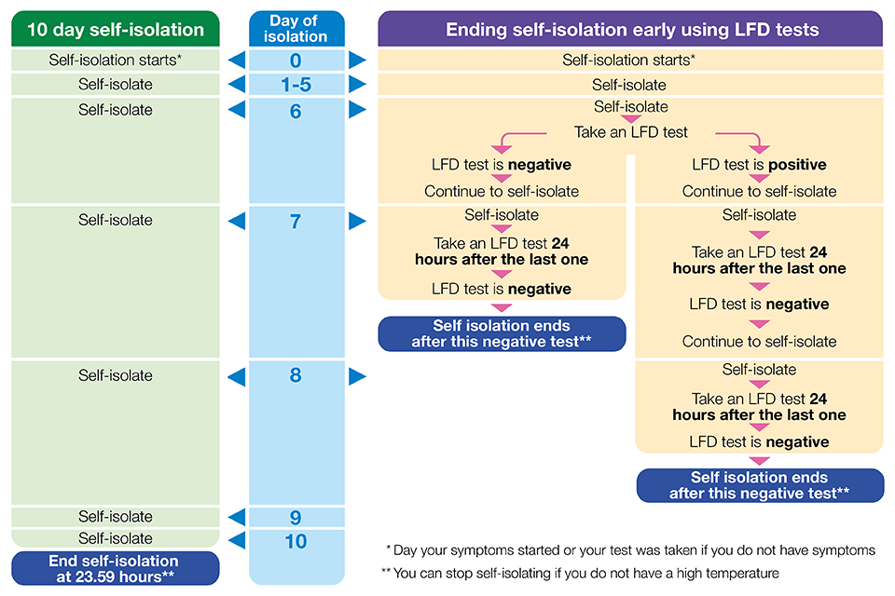

NB: An adult is considered fully-vaccinated from two weeks after having received two doses of an approved vaccine (such as Pfizer/BioNTech, AstraZeneca or Moderna/Spikevax) or one dose of the single-dose Janssen vaccine.

PLEASE ADHERE TO THE LATEST GOVERNMENT GUIDLINES REGARDING ISOLATION. THEY CHANGE DAILY AND THE LATEST GUIDELINES ARE THE ONES WE FOLLOW.

All the above is in place to protect Staff and Children as much as is physically possible. Nothing in the midst of this unprecedented situation is ‘risk free’ but please be assured we are and have done and will continue to do our utmost best to make Holmhirst Pre School as safe as we possibly can. We will continue and are committed to following Government guidelines and those of Public Health England.

Please help us by following the above procedures, and any additions / updates will be communicated to you as and when they arise.

Review Date – Ongoing

